 **Aidence Technologies Private Limited**



August 25th, 2022

**Ms. Akshara Tiwari,** Employee ID - 100026 IT Recruiter

**Through: Department Head**

Dear Akshara,

**Relieving Letter**

This is to intimate to you that you are relieved from the services of the company on August 25th, 2022 after office hours.

We would like to keep on record the appreciation of the management of the services you rendered during your association with Aidence Technologies Pvt. Ltd.

We wish you success in all your new endeavors. Thanking you,

Yours Sincerely,

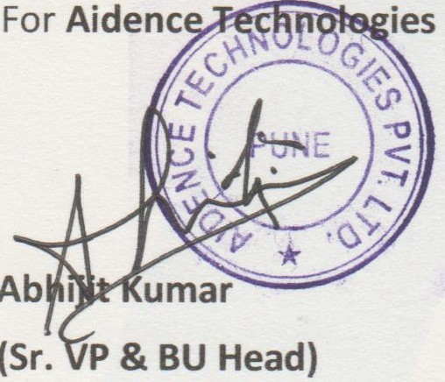**Private Limited**

 **Aidence Technologies Private Limited**



August 25th, 2022

**SERVICE CERTIFICATE**

Name of the employee: Akshara Tiwari Designation: IT Recruiter

Department: Recruitment Operations

Date of Joining: April 12th, 2022

Date of Leaving: August 25th, 2022 Reason for Leaving: Resignation Conduct: Good

For **Aidence Technologies Private Limited**

